Assignment-Chapter 9&10 (100 points)

Student Name: Karri Jayadeep Reddy ID: 664646469

1. Please run the following two commands and observe the differences of two graphs. Write the difference and the reasons. (10 points)

a. p <-ggplot(heightweight,aes(x=ageYear,y=heightIn)) +geom_point()

p + theme(axis.title.x =element_text(colour="red")) + theme_bw()

b. p + theme_bw() + theme(axis.title.x =element_text(colour="red",size=12))

In graph a, the theme()beforesthe theme specification. Anything set by the theme() was unset

by theme_bw(). We couldn’t see any effect on the graph.

In graph b, the theme()works since it was set after theme_bw().The theme()term sets the

colour of the element x to red.

1. Use the PlantGrowth data frame to draw following graphs, respectively. Write down the used functions in ggplot2 (25 points)

(a)

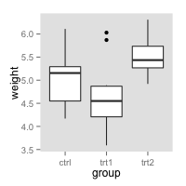

(b)

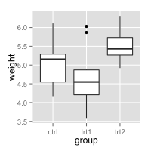

(c)

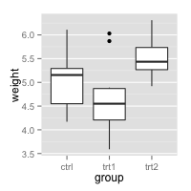

(d)

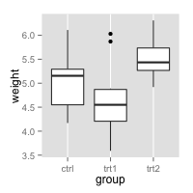

(a)

# Hide all the gridlines

bp + theme(panel.grid.minor=element_blank(),

panel.grid.major=element_blank())

(b)

# Hide just the minor gridlines

bp + theme(panel.grid.minor=element_blank())

(c)

# Hide all the vertical gridlines

bp + theme(panel.grid.minor.x=element_blank(),

panel.grid.major.x=element_blank())

(d)

# Hide all the horizontal gridlines

bp + theme(panel.grid.minor.y=element_blank(),

panel.grid.major.y=element_blank())

1. Please use the DF1 data frame to draw following graphs, respectively. Write down the used functions in ggplot2 (40 points)

DF1 <- data.frame(x = 1:10, y = 1:10, gp = factor(rep(1:2, each = 5)))

p0 <- ggplot(DF1, aes(x = x, y = y, colour = gp)) + geom_point()

(a)

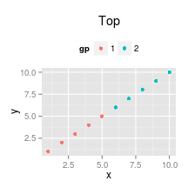

(b)

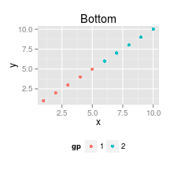

(c)

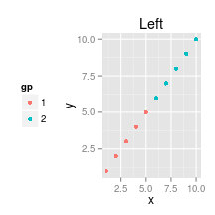

(d)

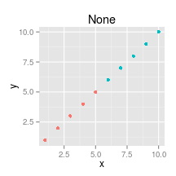

(e)

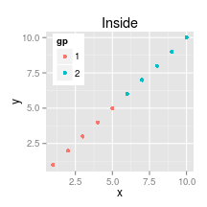

(f)

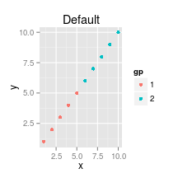

Answers:

p0 + theme(legend.position = "top") + ggtitle("Top")

p0 + theme(legend.position = "bottom") + ggtitle("Bottom")

p0 + theme(legend.position = "left") + ggtitle("Left")

p0 + theme(legend.position = "none") + ggtitle("None")

p0 + theme(legend.position = c(0.15, 0.8)) + ggtitle("Inside")

p0 + ggtitle("Default")

1. Please use the DF1 data frame to draw following graphs, respectively. Write down the used functions in ggplot2 (25 points)

(a)

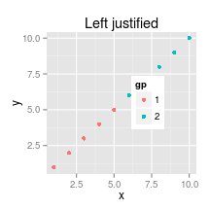

(b)

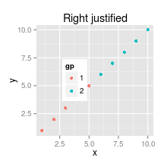

(c)

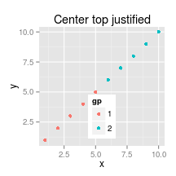

(d)

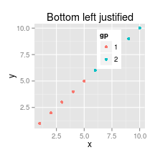

Answers:

p0 + theme(legend.position = c(0.5, 0.5), legend.justification = "left") + labs(title = "Left

justified")

p0 + theme(legend.position = c(0.5, 0.5), legend.justification = "right") + labs(title = "Right

justified")

p0 + theme(legend.position = c(0.5, 0.5), legend.justification = c("center", "top")) + labs(title

= "Center top justified")

p0 + theme(legend.position = c(0.5, 0.5), legend.justification = c("left", "bottom") ) +

labs(title = "Bottom left justified")